Saving Water: Alternate Wetting Drying (AWD)

Water Scarcity
Worldwide, water for agriculture is getting increasingly scarce. By 2025, 15-20 million hectares of irrigated rice may suffer water scarcity. Interventions to respond to water scarcity are called “water-savings” and imply a reduced use of irrigation water.

What is AWD?
Alternate Wetting and Drying (AWD) is a water-saving technology that lowland (paddy) rice farmers can apply to reduce their water use in irrigated fields. In AWD, irrigation water is applied to flood the field a certain number of days after the disappearance of ponded water. Hence, the field is alternately flooded and non-flooded. The number of days of non-flooded soil in AWD between irrigations can vary from 1 day to more than 10 days.

How to implement AWD?
A practical way to implement AWD is to monitor the depth of ponded water on the field using a ‘field water tube’. After irrigation, the depth of ponded water will gradually decrease. When the ponded water has dropped to 15 cm below the surface of the soil, irrigation should be applied to re-flood the field with 5 cm of ponded water. From one week before to one week after flowering, ponded water should always be kept at 5 cm depth. After flowering, during grain filling and ripening, the water level can drop again to 15 cm below the surface before re-irrigation.

AWD can be started a few days after transplanting (or with a 10-cm tall crop in direct seeding). When many weeds are present, AWD can be postponed for 2-3 weeks until weeds have been suppressed by the ponded water. Local fertilizer recommendations as for flooded rice can be used. Apply fertilizer N preferably on the dry soil just before irrigation.

Safe AWD
The threshold of 15 cm water depth (below the surface) before irrigation is called ‘Safe AWD” as this will not cause any yield decline. In Safe AWD, water savings are in the order of 15-30%. After creating confidence that Safe AWD does not reduce yield, farmers may experiment by lowering the threshold level for irrigation to 20, 25, 30 cm depth, or even deeper. Lowering the threshold level for irrigation will increase the water savings, but some yield penalty may occur. Such a yield penalty may be acceptable when the price of water is high or when water is very scarce.

The Field Water Tube
A tube can be made of 40-cm long plastic pipe or bamboo, and have a diameter of 15 cm or more so that the water table is easily visible. Perforate the tube with holes on all sides. Dig the tube in the soil so that 20 cm protrudes above the soil surface. Take care not to penetrate through the bottom of the plow pan. Remove the soil from the inside so that the bottom of the tube is visible. Check that the water table inside the tube is the same as outside the tube. The tube can be placed in a flat part of the field close to a bund, so it is easy to monitor the ponded water depth.
Field water tube from PVC
Note the holes on all sides

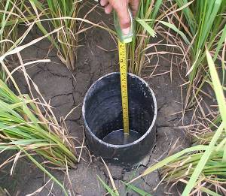
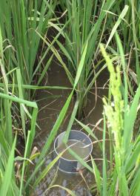
Water at 15 cm depth:
Time to irrigate and flood the field again
A Field tube under flooded conditions

Developed with input from: B.A.M. Bouman and R. M. Lampayan

Find Out More about Alternate Wetting and Drying:
Send an email to: r.lampayan@cgiar.org.
Visit http://www.knowledgebank.irri.org.
Download the book “Water management in irrigated rice -
Coping with water scarcity” at: http://books.irri.org/9789712202193_content.pdf
or at: http://www.irri.org/publications/techbulletin/tech.asp?id=10

